Ecclesfield Group Practice  96a Mill Road, Ecclesfield, Sheffield, S35 9XQ  Tel: 0114 2469030  SHECCG.EcclesfieldGP@nhs.net |  |  |  |  | Ecclesfield Group Practice  Charges For Non-NHS Services (Private Charges) Explained

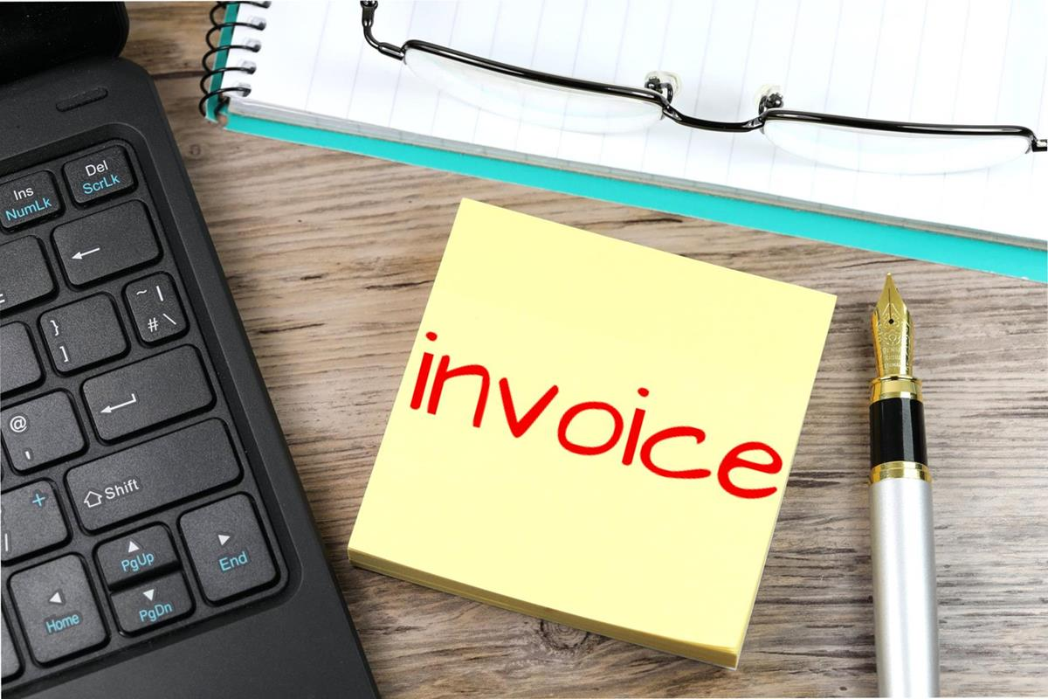  Why do GPs charge fees? Your questions answered.  Isn't the NHS supposed to be free?  The National Health Service provides most health care to most people free of charge, but there are exceptions, for example prescription charges, and there are a number of other services for which fees are charged. This is because the service is not covered by the NHS, for example medical reports for insurance companies, claim forms for referral to private care and other letters and forms which require the GP to review the patient’s medical record.  Surely the GP is being paid anyway?  GPs are not employed by the NHS. They are self-employed and have to cover their costs (staff, buildings, heating, lighting etc) in the same way as any small business. The NHS pays the doctor for specific NHS work but for non-NHS work the fee has to cover the GPs costs. | Do GP’s have to do non-NHS work for their patients?  With certain limited exceptions such as a GP confirming that a patient is not fit for jury service GP’s DO NOT have to carry out non-NHS work. Many GP’s however will always attempt to assist their patients and carry out this work  What is covered by the NHS and what is not?  The governments contract with GPs covers medical services to NHS patients. In recent years more and more organisations have been involving GPs in a whole range of non-medical work.  Examples of non-NHS services for which GPs can charge their NHS patients are;  - Certain travel vaccinations  - Private medical insurance reports  - Holiday cancellation claim forms  - Referral for private care forms  - Letters/forms requested by, or on behalf of, the patient  - Medical Examinations  Examples of non-NHS services for which GPs can charge other institutions are;  - Medical reports for an insurance company  - Some reports from DSS/Benefits agency  - Examinations of local authority employees | Why does it sometimes take my GP a long time to complete my form?  Time spent completing forms and preparing reports takes the GP away from the medical care of his / her patients. GPs have a very heavy workload and paperwork takes up an increasing amount of their time.  I only need a GPs signature-what is the problem?  When a GP signs a certificate or completes a report, it is a condition of remaining on the Medical Register that they only sign what they know to be true. Therefore, in order to complete even the most simplest of forms, the GP needs to check the patients entire medical record. Carelessness or inaccurate report can have serious consequences for the GP.  Why do I need to pay upfront?  In the past we have completed reports and forms before payment has been made, but sadly there have been many occasions when the GP has completed the work, but the payment has not been made. Therefore, the fee must be paid in advance at the time of the request for the letter or form to be completed is made or when the appointment for the medical is booked.

